**MCA & M.Sc THIRD SEMESTER-2023**

**WEB PROGRAMMING**

**LAB PROGRAMS LIST**

**Lab1:**

**AIM**: Write a HTML program to display all types of HTM lists.

**Procedure:**

1. Start
2. Use a container tag, HTML.
3. Within the Html tag, use HEAD tag.
4. Give title as a Different types of lists, with in the title tag.
5. Close title and head tags.
6. Use body tag. Within the body tag use H1, Bold and Underlined tags.
7. Use Unordered list tag, as a <ul>.
8. With in the <ul> tag , take a sub item list tag known as <li> list item tag.
9. Within the <ul> tag use another <ul> tag as nested list tags.
10. Use ordered list tag as a <ol>.
11. With in the <ol> tag , take a sub item list tag known as <li> list item tag.
12. Close <ul> and <ol> tags properly.
13. Close Body tag and HTML tags.
14. Stop.

**Program:**

<html>

<head>

<title>

different types of lists

</title>

</head>

<body>

<h1><b><u>The best features of internet:</u></b></h1>

<ul>

<li>you can meet new people from countries around the world</li>

<li>you have access to new media as it becomes public:

<ul>

<li>New games</li>

<li>New application</li>

<ol>

<li>For business</li>

<li>For pleasure</li>

</ol>

</li>

<li>Around the clock news</li>

<li>search engines</li>

<li>Shopping</li>

<li>Programming</li>

<ol>

<li>XML</li>

<li>Java</li>

<li>scripts</li>

<li>New languages</li>

</ol>

</li>

</ul>

</li>

<li>Links</li>

<li>Keeping in touch with old friends</li>

<li>It is the technology of the feature</li>

</ul>

</body>

</html>

**OUTPUT:**

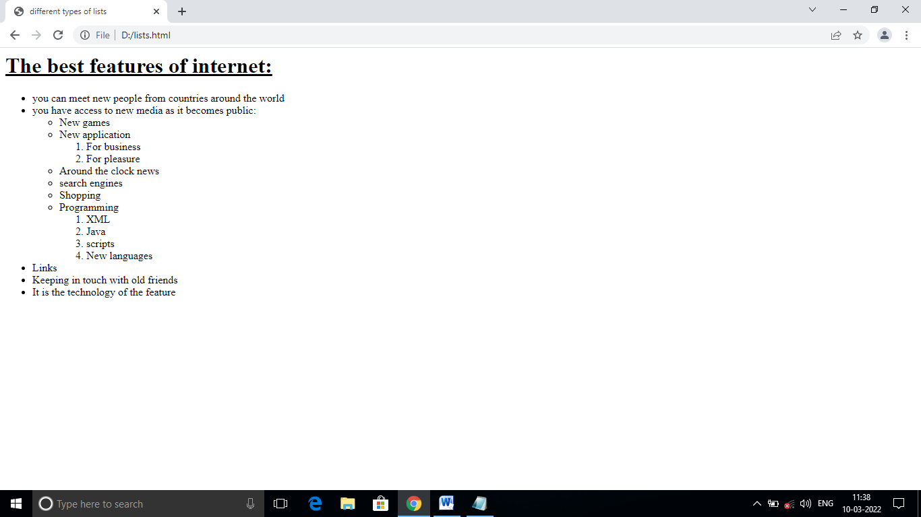

**Lab-2:**

**AIM:** Write a HTML program to create a letter head of your college, using the following style

1. Use header tags to format college name and address

**Procedure:**

Step1: start

Step2: use HTML tag with in the tag use head tag.

Step3: Within the head tag, use Title tag.

Step: Take title as Headers.

Step5: Take body tag, use bgcolor attribute in body tag.

Step6:Use headers tags <h1>,<h2>,<h3>,<h4>,<h5> and <h6>

Step7:close all headers tags properly.

Step8:close body tag and html tag

Step9: Stop.

**Program:**

<html>

<head>

<title>Headers</title>

</head>

<body bgcolor="Blue”>

<h2 align="center">Department of Computer Science</h2>

<h1 align="center">RAO'S INSTITUTE OF COMPUTER

SCIENCE</h1>

<h3 align="center">(Affiliated to V.S.University)</h3>

<h3 align="center">(Approved by A.I.C.T.E.,)</h3>

<h4 align="center">NEW DELHI</h4>

<h5 align="center">Nellore-524001</h5>

</body>

</html>

**OUTPUT:**

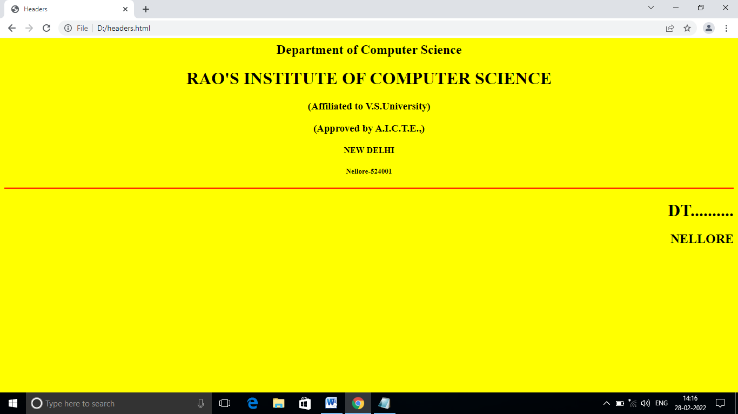

**Lab 3:**

**AIM:** Write a HTML program to create a webpage by using Hyperlinks.

**Procedure:**

Step1: start

Step2: Use html tag, within that tag use head tag.

Step3: Within the head tag use title tag.

Step4: Take title as Hyperlinks. close title tag.

Step5: close head tag.

Step6: Take body tag. With in the body tag, use anchor tag.

Step7: With in the Anchor tag, use href(hyperreference) attribute.

Step8: take three links as fruits, flowers and animals.

Step 9: save the main program “link.html”.

Step10:close anchor tag, body tag and html tags properly.

Step11: Take another notepad, write the code for fruits.html.

Step12: Within that use unordered lists, and take sub tag as list item tag.

Step13.Take another notepad, write the code for flowers.html.

Step14: Within that use unordered lists, and take sub tag as list item tag.

Step15: Take another notepad, write the code for animals.html

Step16: Within that use unordered lists, and take sub tag as list item tag.

Step17: close head, body and html tags properly for all links.

Step18:stop.

**Program:**

* **Link.html**

<html>

<head>

<title>Hyperlinks</title>

<h1>

<u>List of fruits ,flowers and animals:</u>

</h1>

</head>

<body>

<a href="fruits.html">fruits</a><br>

<a href="flowers.html">flowers</a><br>

<a href="animals.html">animals</a>

</body>

</htmL>

**PROGRAM ON FRUITS:**

* **Fruits.html**

<html>

<head>

<h1><b><u>some of the fruits are:</u></b></h1>

</head>

<body>

<ul>

<li><p>Apple</p></li>

<li><p>Pine Apple</p></li>

<li><p>Banana</p></li>

<li><p>Grapes</p></ll>

<li><p>Orange</p></li>

<li><p>Water Lemon</p></li>

</ul>

</body></html>

**PROGRAM ON FLOWERS:**

* **Flowers.html**

<html>

<head>

<h1><b><u>some of the flowers are:</u></b></h1>

</head>

<body>

<ul>

<li><p>Rose</p></li>

<li><p>Lily</p></li>

<li><p>Lotus</p></li>

<li><p>Blue water lily</p></ll>

<li><p>Cobra saffron</p></li>

<li><p>Elephant creeper</p></li>

</ul>

</body></html>

**PROGRAM ON ANIMALS:**

* **Animals.html**

<html>

<head>

<h1><b><u>some of the Animals are:</u></b></h1>

</head>

<body>

<ul>

<li><p>Dog</p></li>

<li><p>Cat</p></li>

<li><p>Lion</p></li>

<li><p>Tiger</p></ll>

<li><p>Elephant</p></li>

<li><p>Horse</p></li>

</ul>

</body></htmL>

**OUTPUT:**

List of fruits ,flowers and animals:

fruits  
flowers  
animals

# some of the fruits are:

* Apple
* Pine Apple
* Banana
* Grapes
* Orange
* Water Lemon

some of the flowers are:

* Rose
* Lily
* Lotus
* Blue water lily
* Cobra saffron
* Elephant creeper

# some of the Animals are:

* Dog
* Cat
* Lion
* Tiger
* Elephant
* Horse

**Lab 4:**

**AIM:** Write a HTML program to create a webpage by using Tables.

**Procedure:**

Step1: start

Step2: Use html tag, within that tag use head tag.

Step3: Within the head tag use title tag.

Step4: Take title as Creating Tables. close title tag.

Step5: close head tag. Take a body tag.

Step6: Within the body use a container tag to create a table that is <table> tag.

Step7:Use border as a attribute in table tag.

Step8: Inside the table tag ,use table row <tr> tag for creating rows. Inside the table row use a

table data tag <td> for insert the data in a particular cell.

Step9: Use two special attributes, rowspan and colspan for merging rows and

coloumns.

Step10. Close all container tags like <tr>, <td> properly.

Step11. Finally close <table> tag.

Step12. Close body and HTML tags.

Step13: stop.

**Program:**

<HTML>

<head>

<title> Creating Tables</title>

</head>

<body>

<table border="5">

<tr>

<th colspan=7>Student Internal marks</th>

</tr>

<tr>

<td rowspan="2">Roll no</td>

<td rowspan="2">Names</td>

<td colspan="5" align="center"> Marks</td>

</tr>

<tr>

<td>HTML</td>

<td>JAVA</td>

<td>DBMS</td>

<td>DS</td>

<td>OS</td>

</tr>

<tr>

<td>1271</td>

<td>suresh</td>

<td>98</td>

<td>97</td>

<td>96</td>

<td>95</td>

<td>93</td>

</tr>

<tr>

<td>1272</td>

<td>Venkatesh</td>

<td>88</td>

<td>87</td>

<td>98</td>

<td>65</td>

<td>89</td>

</tr>

<tr>

<td>1273</td>

<td>Gopichand</td>

<td>76</td>

<td>45</td>

<td>56</td>

<td>89</td>

<td>67</td>

</tr>

</body>

</html>

**4. OUTPUT:**

|  |  |  |  |  |  |  |
| --- | --- | --- | --- | --- | --- | --- |
| Student Internal marks | | | | | | |
| Roll no | Names | Marks | | | | |
| HTML | JAVA | DBMS | DS | OS |
| 1271 | Suresh | 98 | 97 | 96 | 95 | 93 |
| 1272 | Venkatesh | 88 | 87 | 98 | 65 | 89 |
| 1273 | Gopichand | 76 | 45 | 56 | 89 | 67 |

**Lab: 5:**

**AIM:**

Write a HTML program to create a web form for entering the student details.

**Procedure:**

Step1: start

Step2: use HTML tag, with in that take Head tag.

Step3:Use body tag, take a special attribute called “bgcolor” to display the

background color the web page.

Step4: use <h1> heading tag for form heading, Next take <hr> tag a horizontal

line is displayed between the form heading and form elements.

Step5: use <form> tag .Inside the form tag use the form elements like

textbox, password, radio buttons, Action buttons, combobox and textarea

fields properly.

Step6: Use <input> container tag and take the attributes are Name, value ,

Type and Size

Step7: We need a space without a break, use an entity called &nbsp. i.e., Non

breakable space entity.

Step8: close the form tag.

Step9: Close the Body tag and Html tags properly.

Step10: Stop.

**PROGRAM**:

<html>

<head></head>

<body bgcolor="yellow">

<h1 align="center">ENTER THE STUDENT DETAILS IN THE FIELDS</h1>

<hr color="red" align="center" size="20%" width="50%">

<h1 align="center">

<form>

Name &nbsp &nbsp &nbsp &nbsp &nbsp &nbsp &nbsp

<input type ="text" name="t1" size="10"><br>

Father's Name&nbsp&nbsp<input type ="text" name=="t2"

size="10"><br>

Date of birth&nbsp &nbsp&nbsp

<input type="text" name="day" size="2">

<input type="text" name="month" size="2">

<input type="text" name="year" size="4"><br>

Qualification &nbsp &nbsp&nbsp<select name="cb1">

<option>SSC</option>

<option>INTER</option>

<option>DEGREE</option>

<option>PG</option>

<option>MCA</option>

<option>MBA</option>

</select><br>

E-mail id &nbsp &nbsp &nbsp &nbsp&nbsp

<input type ="text" name="t3" size="10"><br>

Password &nbsp &nbsp &nbsp &nbsp

<input type ="password" name="t5" size="10"><br>

Religion

&nbsp &nbsp &nbsp &nbsp &nbsp &nbsp <input type="radio" name="gender">Hindu

&nbsp<input type="radio" name="gender">Muslim<br>

&nbsp &nbsp &nbsp &nbsp &nbsp &nbsp &nbsp &nbsp &nbsp

&nbsp &nbsp &nbsp &nbsp<input type="radio" name="gender">Christian

<input type="radio" name="gender">Buddhism<br>

Special skills&nbsp

<input type="checkbox">Reading books

<input type="checkbox">Singing<br>

&nbsp &nbsp &nbsp &nbsp &nbsp &nbsp &nbsp &nbsp &nbsp &nbsp &nbsp<input type="checkbox">Coins collecting

<input type="checkbox">Making papers<br>

Describe yourself<textarea name="ta1"></textarea><br>

&nbsp &nbsp &nbsp &nbsp <input type="submit" value="submit">

&nbsp &nbsp &nbsp &nbsp <input type="Reset" value="Reset">

</form></h1>

</body>

</html>

Output:

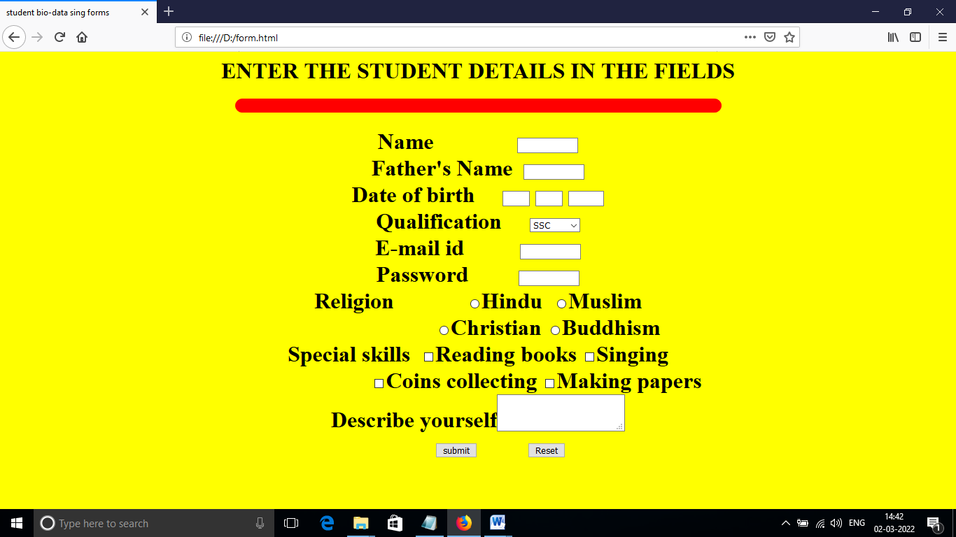

**Lab 6:**

**AIM:** Write a HTML program to use div element, display the html elements as a BOX MODEL.

**Procedure:**

Step1: start

Step2: use HTML tag , with in that use HEAD tag.

Step3: With in the HEAD tag, take title tag, the title is “Box Model”.

Step4: With in the head tag use a container tag known as “style”.

Step5: Use CSS syntax , apply properties and values like background-color,text-

align, border-width,border-style and border-color etc.

Step6: Take Div element.Close style tag.

Step7: Close head tag. Take body tag

Step8: With in the body tag use div tag with class attribute.

Step9:close body and HTML tags properly.

Step10: stop.

**Program:**

<html>

<head>

<title>Box Model</title>

<style>

body{background-color:#11dd44}

div{text-align:center}

.thick{border-width:thick}

.thin{border-width:thin}

.medium{border-width:medium}

.groove{border-style:groove}

.red{border-color:red}

.blue{border-color:blue}

</style>

</head>

<body>

<div class="thick groove"> This text has a border</div><br>

<div class="thin groove blue"> This text has a border</div><br>

<div class="thin red groove"> This text has a thin red line.........</div><br>

<div class="thick groove"> This text has a border</div><br>

<p class="medium red groove"> This paragraph has a red border</p><br>

<p class="thick groove blue"> This paragraph has a blue color</p><br>

<div class="thin medium groove"> This text has a groove border</div>

</body>

</html>

Output:

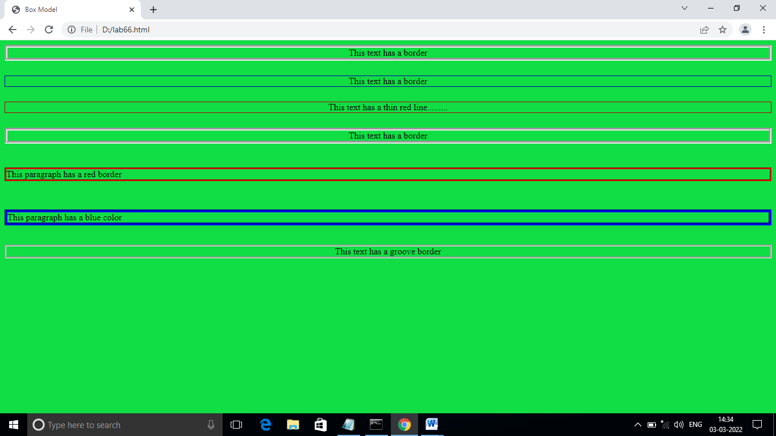

**Lab 7:**

**AIM:** Write a HTML program to create a webpage by using Math Object with different methods.

**Procedure:**

Step1: start

Step2: use html tag, with in that use head tag.

Step3: Inside the head tag, use title tag, the title of webpage is “New

document”.

Step4: Use script tag with language attribute.

Step5: Take function name as pressed().

Step6: Inside the pressed(). Take two variable res and res1.

Step7: Use window object with method name as alert().

Step8: Use the Math object methods are max(),pow(),sqrt() and exp().

Step9:Close script tag and head tag.

Step10: Use body tag, with in that take <form> tag.

Step11: The attributes are used in the form tag are name and action.

Step12: Create two text boxes for entering the integer values.

Step13: Close form tag and body tag and Html tags.

Step14: stop.

**Program:**

<html>

<head>

<title>New document</title>

<script language="javascript">

function pressed()

{

var res=cal.n1.value;

var res1=cal.n2.value;

window.alert("The maximum value is"+Math.max(res,res1)+

"The sin value of"+res+"is"+Math.sin(res)+

"The power value is"+Math.pow(res,res1)+

"The sqrt value is"+Math.sqrt(res,res1)+

"The expo value of"+Math.exp(res1));

}

</script>

</head>

<body>

<form name="cal" action="">

Enter first number&nbsp &nbsp &nbsp<input type="text" name="n1" size="5"><br><br>

Enter second number<input type="text" name="n2" size="5"><br><br>

<input type="button" name="b1" value="calculate" onclick="pressed()">

</form>

</body>

</html>

**Output:**

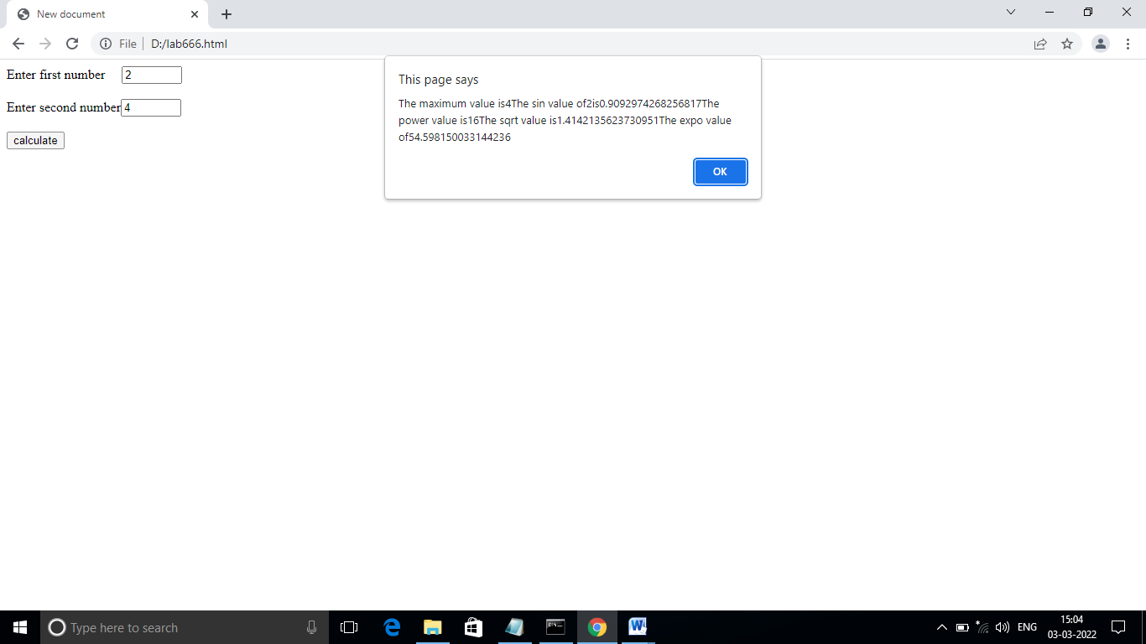

**Lab 8:**

**AIM: AIM: Write a HTML program using DOM collections.**

**Procedure:**

Step1: start

Step2: Take HTML tag. With in that use Body tag.

Step3: DOM means document object Model. DOM is used to accessing the

documents.

Step4: With in the body tag, use <h2> and <p> tags. For displaying the text in

big size in a paragraph.

Step5: Use script tag.

Step6: With in the script tag. The DOM contains a method called

getElementById() and a property called innerHTML.

Step7: The DOM method is accessed the HTML elements and the property is

used to changes can be done by the HTML document

Step8: close script tag

Step9: close body and html tags properly.

Step10: stop.

**Program:**

<html>

<body bgcolor="#11ff44">

<h2>JavaScript HTML DOM</h2>

<p>Hello World!</p>

<p>Hello Norway!</p>

<p id="demo"></p>

<script>

var myCollection = document.getElementsByTagName("p");

document.getElementById("demo").innerHTML =

"The innerHTML of the second paragraph is: " +

myCollection[1].innerHTML;

</script>

</body></html>

**Output:**

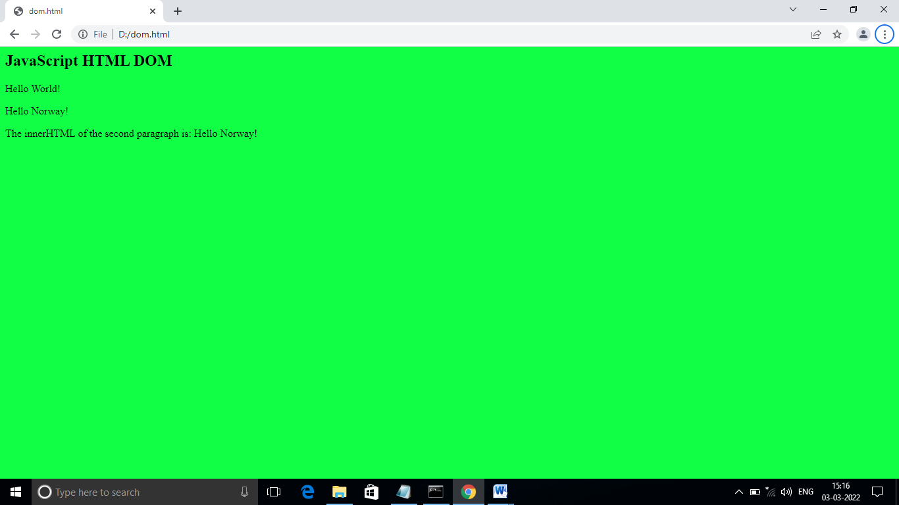

**Lab 9:**

**AIM:** write a HTML program use counter-controlled repetition to display 10 times user input in dialog.

**Procedure:**

Step1: start

Step2: Use Html tag, inside that use head tag.

Step3: Take script tag

Step4: Take variables as grade, total, average, gradevalue, gradecounter.

Step5: Initialise total=0, gradecounter=1.

Step6:use while looping statement.

Step7: use window object with prompt method.

Step8: grade=window.prompt().

Step9: convert the string value into an integer , use the method called

parseint().

Step10:total=total + gradevalue, increase the gradecounter value use increment

operator.

Step11: Display the output , use the output statement is, document.writeln().

Step12: close script tag and head tag.

Step13: use body tag and take a <p> tag to display the sentence.

Step14: close body tag and html tag.

Step15: stop.

**Program:**

<html>

<head>

<script language="javascript">

var grade,total=0 ,average,gradevalue,gradecounter=1;

while(gradecounter<=10)

{

grade=window.prompt("enter integers","0");

gradevalue=parseInt(grade);

total=total+gradevalue;

gradecounter=gradecounter+1;

}

average=total/10;

document.writeln("<h1>class average value is:"+average+"</h1>");

</script>

</head>

<body>

<p> click refresh to run the script again</p>

</body>

</html>

**Output**:

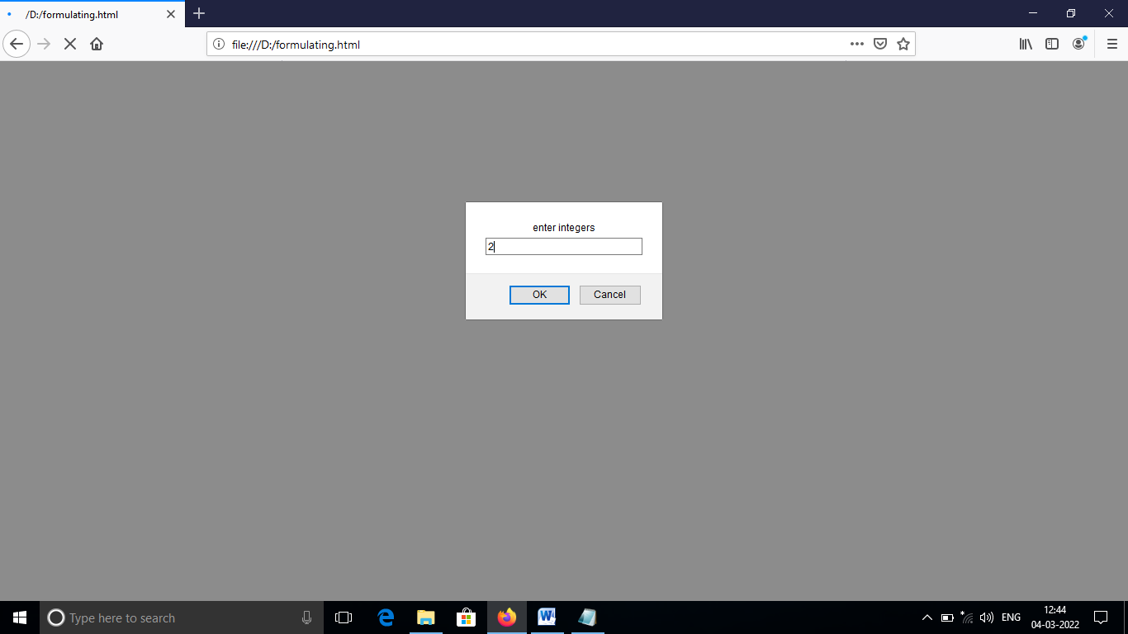

This dialog is displayed 10 times user input is 100,88,93,55,68,77,83,95,73, and,62.

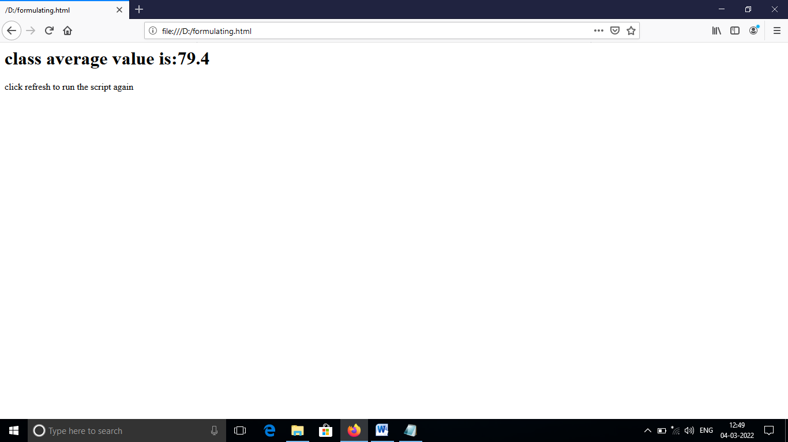

**Lab 10:**

**AIM:** Write a HTML program use javascript to display the arrays

**Procedure:**

Step1: start

Step2: use Html tag. Within that use Head tag.

Step3: use script tag. Take function name as start().

Step4: Inside the function take array name as “colors”.

Step5: creating arrays using “new “ dynamic memory allocation operator.

Step6: Take another function as outputArray().

Step7: Inside the function outputArray(), use for loop statement.

Step8: close script tag and head tag.

Step9: use body tag, with in that use an event called “onload”.

Step10: close body and Html tags properly.

Step11: stop

**Program:**

<html>

<head>

<script language="javascript">

function start()

{

var colors=new Array("cyan","magenta","yellow","black");

outputArray(" Array colors contains",colors);

}

function outputArray(header,theArray)

{

document.writeln("<h2>"+header+"</h2>");

for(var i=0; i<theArray.length;i++)

document.writeln("<h1>"+i+"<br>"+theArray[i]+"</h1>");

}

</script>

</head>

<body onload="start()">

</body>

</html>

**Output:**

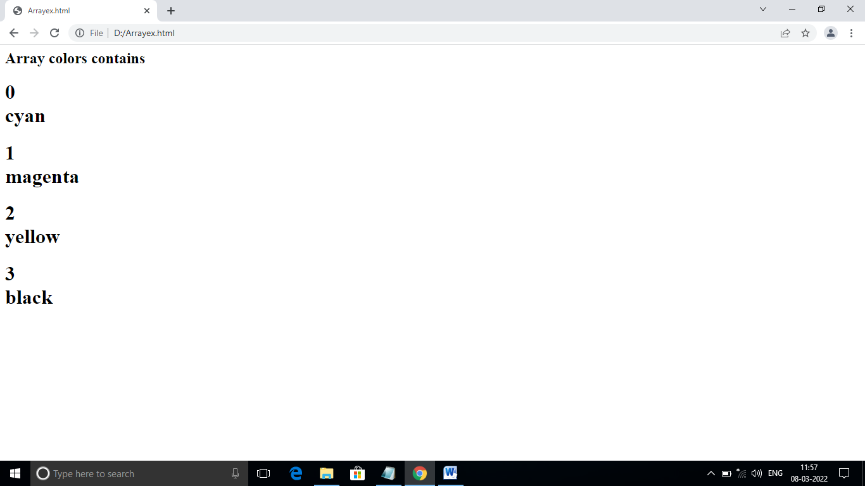

**Lab 11:**

.

**AIM:** Write a HTML program, to illustrate the java script variables, scope

rules

**Procedure:**

Step1: start

Step2: Take HTML tag, with in that use head tag.

Step3: Inside the head tag, take script tag , with language attribute the value is

javascript

Step4: Take variable x, and initialize to 1.

Step5: Use function start(), with in that declare another value for variable x is5.

Step6: With in the start(), take another two functions, those are, functionA and

functionB.

Step7: In functionA, use a local variable, and initialize to 25.

Step8: Display statement is used to display the local variable , that is

implemented in functionA.

Step9: In function, use the global variable, that is declared in the before function

start().

Step10: In functionA increment the local variable use increment operator, and in

function , use assignment operator for global variable.

Step11: Close script and Head tags properly.

Step12: Take a body tag, with in that use a “onload” event handler.for calling

the start() function.

Step13: close body and Html tags properly.

Step14: Stop.

**Program:**

<html>

<head>

<script language="javascript">

var x=1;

function start()

{

var x=5;

document.writeln("local value of x in start function is:"+x+"<br><br>");

functionA();

functionB();

functionA();

functionB();

functionA();

functionB();

}

function functionA()

{

var x=25;

document.writeln("local value of x is:"+x+"<br>");

x++;

document.writeln("local value of x is:"+x+"<br><br>");

}

function functionB()

{

document.writeln("global value of x is:"+x+"<br>");

x*=10;

document.writeln("global value of x is:"+x+"<br><br>");

}

</script>

</head>

<body onload="start()">

</body>

</html>

**Output:**

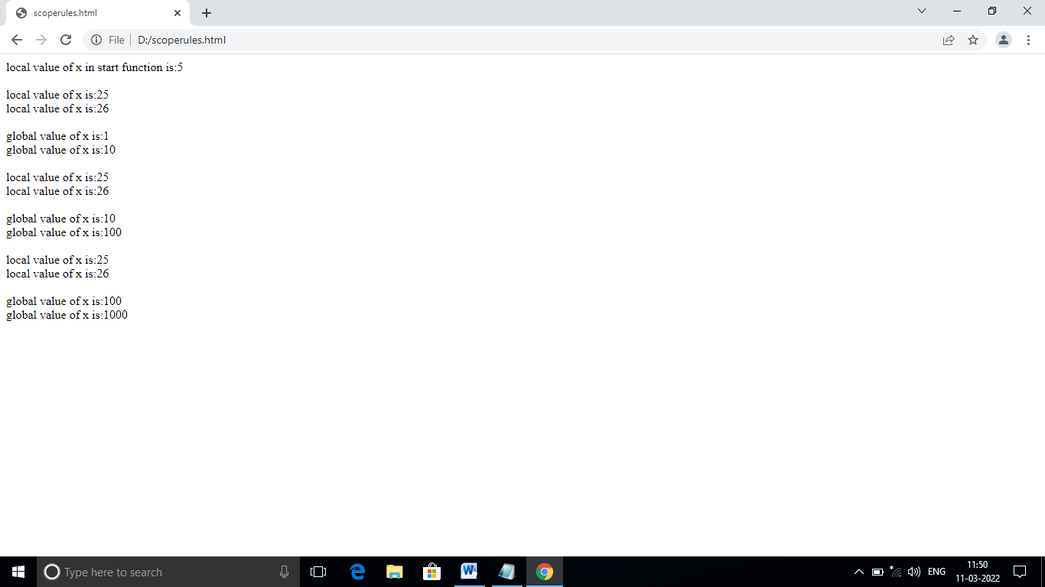

**Lab 12:**

**AIM:** Write a HTML program, to display the CSS backgrounds and positioning elements of the web page.

**Procedure:**

Step1: start

Step2: Take a HTML tag, with in that use, head tag. Use title as Absolute

Positioning apply in the title tag.

Step3: Use style tag, with in that use css syntax for the body element and

Paragraph element.

Step4: close style tag and head tags properly.

Step5: Take a body tag, with in that use img tag,and position, top,left,right,

bottom properties.

Step6: Inside non-container image tag, use a special attribute called “src”, it

denotes the “url” of the image.

Step7: Set the properties like background-position,background-

attachment,background-repeat for fixed position image with no

repetitions.

Step8: close the body tag and paragraph tags properly.

Step9: close the HTML tag.

Step10: stop.

**Program:**

<html>

<head>

<title> Absolute positioning</title>

<style>

body{background-image:url(flower1.jpg);background-

attachment:fixed;background-repeat:no-repeat}

p{font-size:large;color:green;font-family:Calibri}

</style>

</head>

<body>

<p> <img src="flower1.jpg" style="position:absolute;top:0px;left:0px" alt="first positioned image"></p>

<p style="position:absolute;top:50px;right:50px;font-size:20pt;color:blue"> Positioned text</p>

<p><img src="flower2.jpg" style="position:absolute;top:20px;left:90px" alt="second positioned image">

<br><br><br><br><br><br><br><br><br>

<p> This example uses the background-image, background-position ans styles to place the imge in the top, left corner of the page.</p>

</body>

</html>

**Output:**

